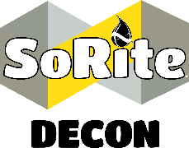
Standard Operating Procedure
Preventive Maintenance – Law Enforcement Transport Vehicle
Scope: SoRite Decon recognizes the dangers associated with transporting prisoners that have been involved in drug possesion. The scope of this standard operating procedure is to ensure the proper utilization of SoRite Decon and SoRite Disinfectant solutions to perform preventative maintenance decon of any prisoner transport vehicle. This will ensure the elimination of potential secondary contamination of dangerous opioids and pathogens.
- If there is visible powder, please refer to Contaminated Surfaces – Small Visible Powder SOP.

- All personnel shall don exam gloves and eye protection.

- Choosing the SoRite Decon solution container of your choice, wet all hard surfaces of the transport vehicle including but not limited to the soles of personnel footwear, bench seats, door panels, floor, and high contact touch points such as door handles.

- To wet hard surfaces, hold the applicator 6” to 8” from the desired surface.

- A SoRite Decon wipe can be used to wipe down electronics such as radios and keyboards.

- All surfaces shall remain wet for a minimum of 60 seconds.

- After 60 seconds, surfaces can be allowed to air dry or be dried using a microfiber towel.

- All surfaces shall then be disinfected utilizing SoRite Disinfectant using the same procedure as SoRite Decon.

- All wipes and gloves shall be disposed of in accordance with local, state, and federal guidelines.

